Microservices with Spring Boot – Account and Loan

1. Software Requirements
Ensure the following software is installed:
- Spring Tool Suite (STS) or Eclipse IDE for Enterprise Java Developers
- Java 17
- Maven 3.6 or higher
- Browser (for accessing Spring Initializr)
2. Folder Setup
- Go to D:\
- Create folder with your employee ID
D:\12345
- Inside that, create:
D:\12345\microservices
3. Create account Microservice Using Spring Initializr
- Open: https://start.spring.io
- Fill in:
  - Group: com.cognizant
  - Artifact: account
- Select dependencies:
  - Spring Web
  - Spring Boot DevTools
- Click Generate, download the ZIP
- Extract the account folder into:
D:\12345\microservices
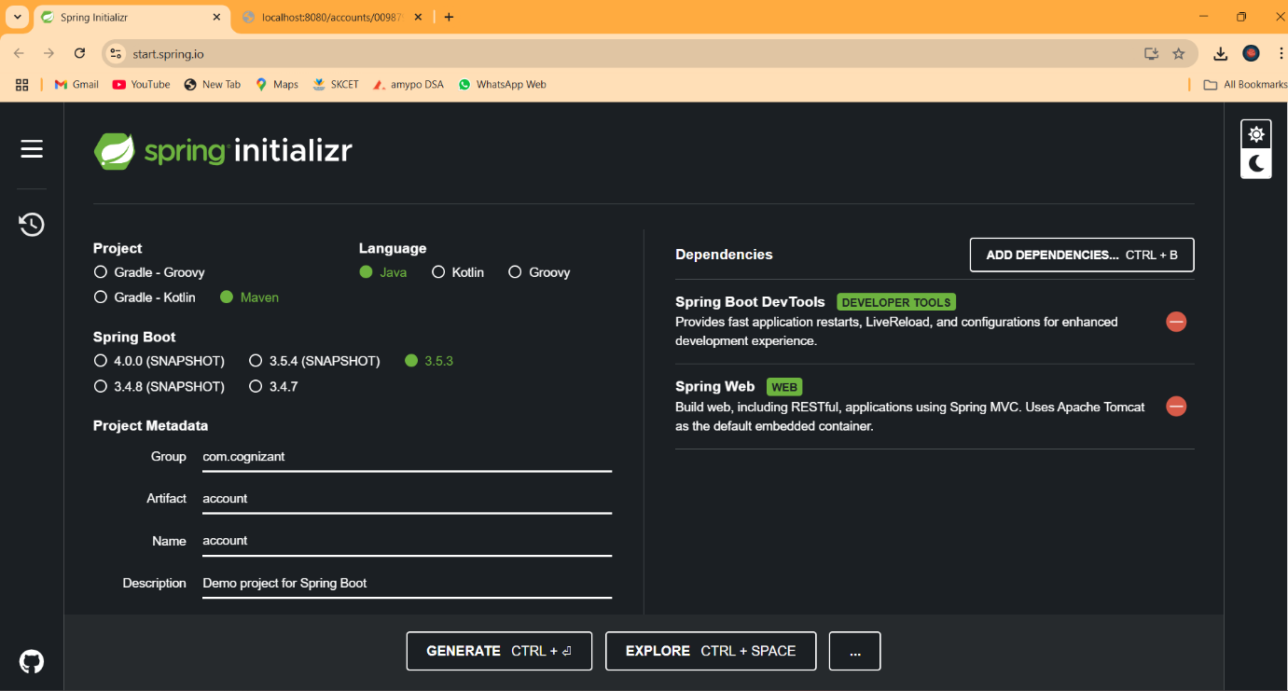

4. Import account Project into STS
- Open STS → File > Import > Maven > Existing Maven Projects
- Browse to:
D:\12345\microservices\account
- Click Finish
5. Add Controller for Account
Create a class:
com.cognizant.account.controller.AccountController
@RestController
@RequestMapping("/accounts")
public class AccountController {

@GetMapping("/{number}")
public Map<String, Object> getAccountDetails(@PathVariable String number) {
Map<String, Object> response = new HashMap<>();
response.put("number", number);
response.put("type", "savings");
response.put("balance", 234343);
return response;
}
}
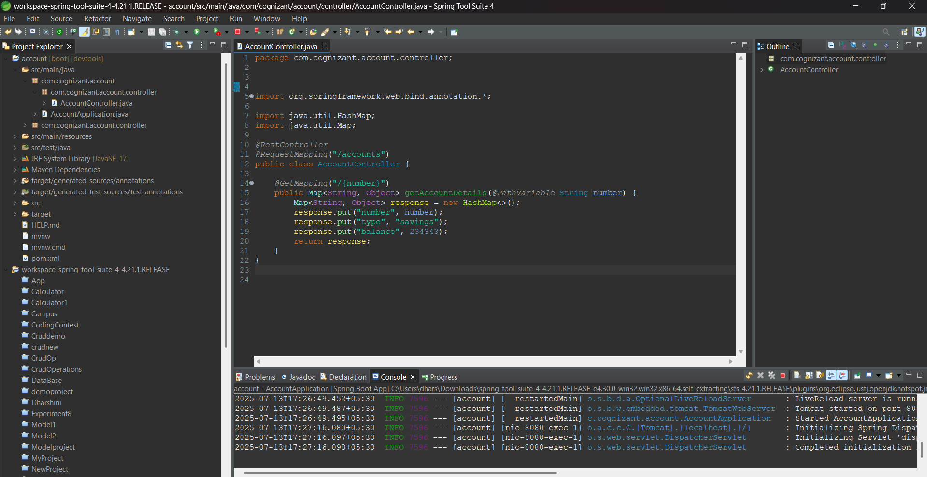

6. Run and Test account Service
- Right-click AccountApplication.java → Run As > Spring Boot App
- Visit in browser:
http://localhost:8080/accounts/00987987973432
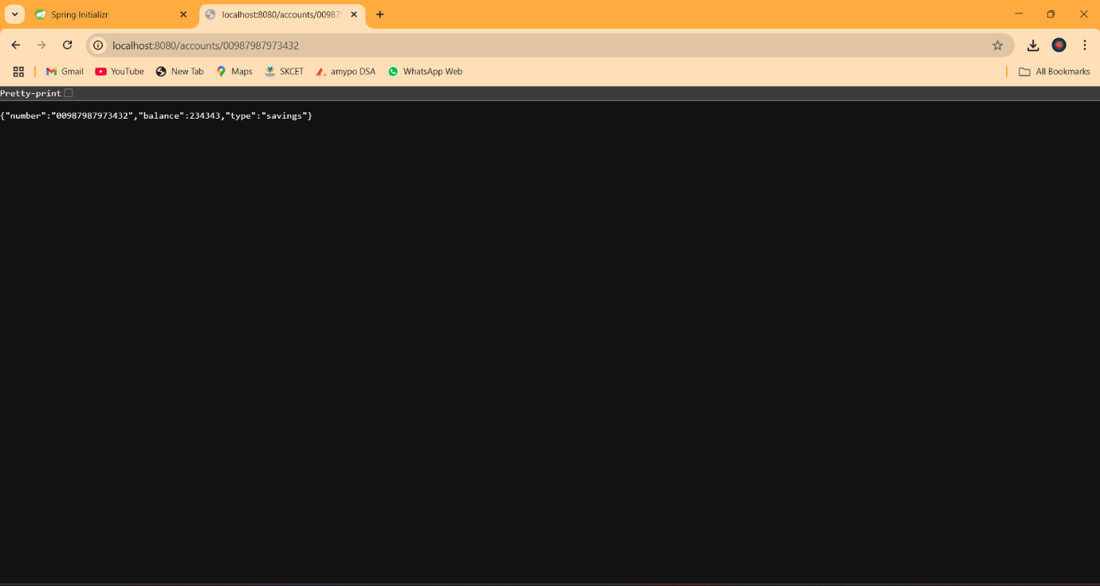

7. Create loan Microservice Using Spring Initializr
Repeat steps like for account, but:
- Artifact: loan
- Package Name: com.cognizant.loan
- Add same dependencies:
  - Spring Web
  - Spring Boot DevTools
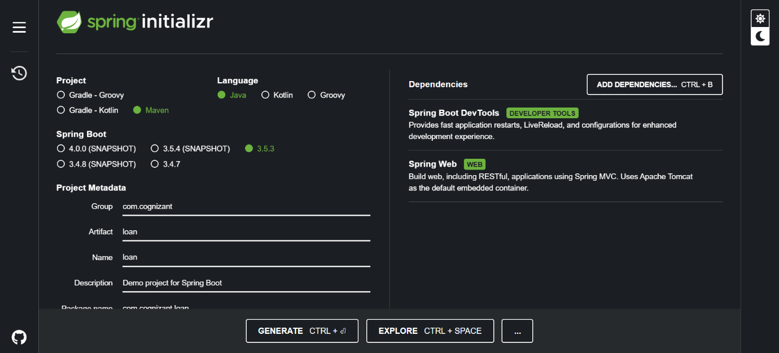

8. Import loan Project into STS
- Go to File > Import > Maven > Existing Maven Projects
- Select:
D:\12345\microservices\loan
- Click Finish
9. Add Controller for Loan
Create a class:
com.cognizant.loan.controller.LoanController
@RestController
@RequestMapping("/loans")
public class LoanController {

@GetMapping("/{number}")
public Map<String, Object> getLoanDetails(@PathVariable String number) {
Map<String, Object> response = new HashMap<>();
response.put("number", number);
response.put("type", "car");
response.put("loan", 400000);
response.put("emi", 3258);
response.put("tenure", 18);
return response;
}
}
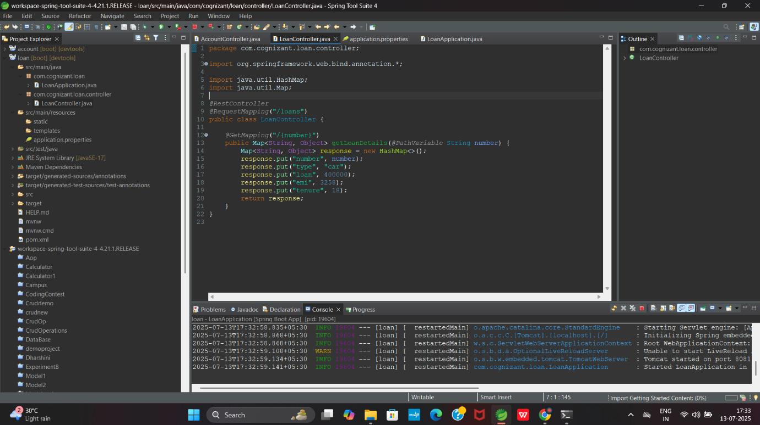

10. Change Port for loan Microservice
- Open: src/main/resources/application.properties
- Add:
server.port=8081
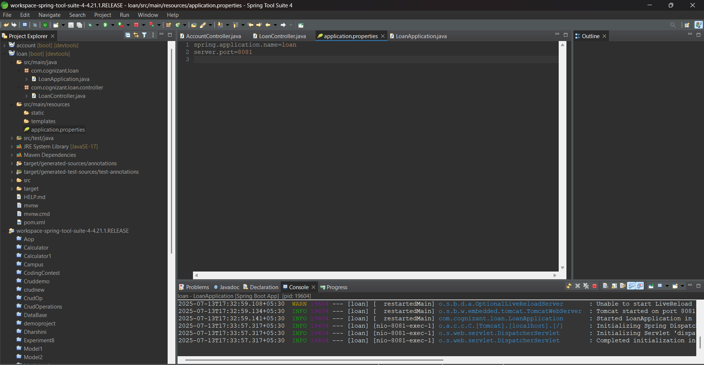

11. Run and Test loan Service
- Right-click LoanApplication.java → Run As > Spring Boot App
- Visit in browser:
http://localhost:8081/loans/H00987987972342
